1. **This logo belongs to**

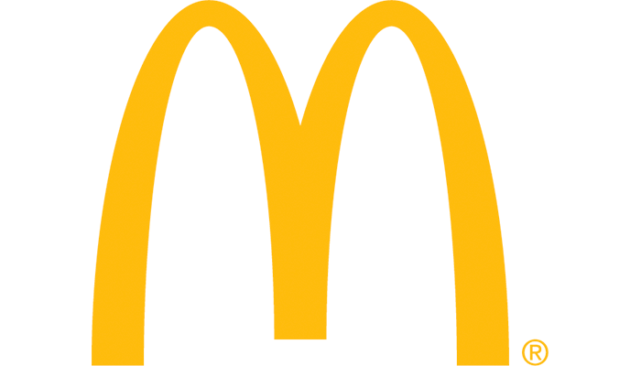

1. Wendy's
2. Taco Bell
3. McDonald's
4. Dominos

**CORRECT- C**

1. **This logo belongs to**

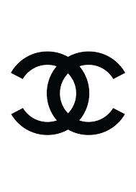

1. Chanel
2. Cartoon Network
3. Chevrolet
4. Christian Dior

**CORRECT- A**

1. **This logo belongs to**

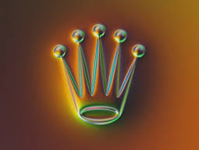

1. Crown Plaza Hotel
2. Thomas Crown Affair movie
3. Crown Casino
4. Rolex

**CORRECT- D**

1. **Can you recognize this logo?**



1. Royal Bank of Scotland
2. HSBC
3. The Common Wealth Games 2010
4. 'Arrow' Van Heusen

**CORRECT- B**

1. **Can you recognize this logo?**

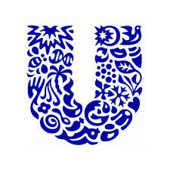

1. United News of India
2. Unilever
3. Uni Klinger Limited
4. Uni Style Image

**CORRECT- B**

1. **Can you recognize this logo?**

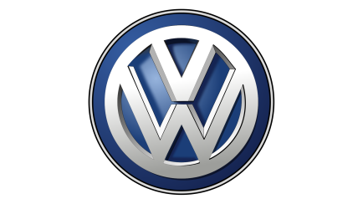

1. B.M.W.
2. Renault
3. Ford
4. Volkswagen

**CORRECT- D**

1. **Can you recognize this logo?**

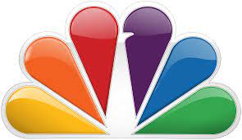

1. IBN
2. CNN
3. ICICI
4. NBC

**CORRECT- D**

1. **Can you recognize this logo?**

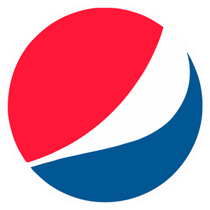

1. Pepsi
2. Mirinda
3. 7UP
4. Coca Cola

**CORRECT- A**

1. **Can you recognize this logo?**

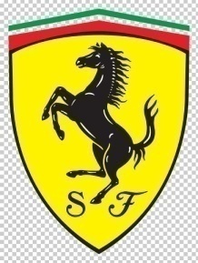

1. Lamborghini
2. Maserati
3. Ferrari
4. Mclaren F1

**CORRECT- C**

1. **This is the logo of.**



1. Kuoni Travels
2. TUI
3. Thomas Cook
4. Smyle Travels

**CORRECT- B**

1. **Can you tell which company's logo is it?**

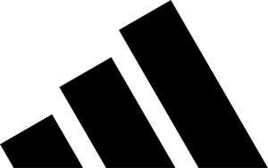

1. Puma
2. Adidas
3. Nike
4. None of the above

**CORRECT- B**

1. **This is an iconic luxury British sports car manufacturer brand. Can you identify its name from the logo?**

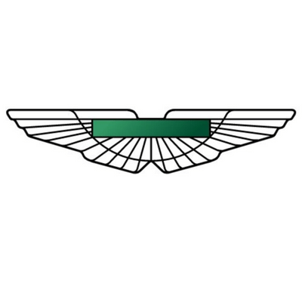

1. Aston Martin
2. Bentley
3. Mercedes
4. Jaguar

**CORRECT- A**

1. **This is also a very popular French brand of automobiles. Identify its company name.**

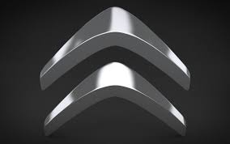

1. Carrefour
2. MICHELIN
3. Renault
4. Citroen

**CORRECT- D**

1. **Guess it's brand name from the logo.**

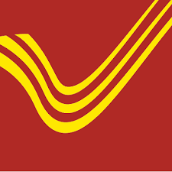

1. India Post
2. DTDC
3. E-Com
4. None of the above

**CORRECT- A**

1. **This is an American multinational telecommunications company. Identify its brand name.**

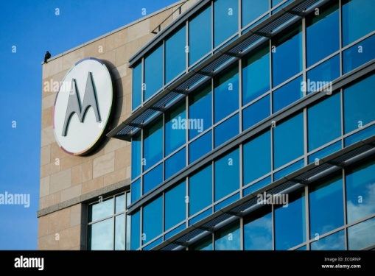

1. Motorola
2. Micromax
3. Nokia
4. Samsung

**CORRECT- A**

1. **This company is one of the leading two-wheeler companies in India. Identify its brand name from the logo.**



1. TATA
2. Yamaha
3. Nissan
4. None of the above

**CORRECT- B**

1. **What brand is this?**

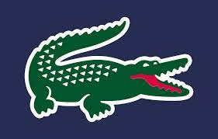

1. Lacoste
2. Gucci
3. Armani
4. Nike

**CORRECT- A**

1. **What brand is this?**

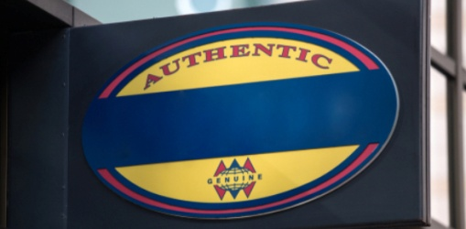

1. Armani
2. Patek and Phillpe
3. Fossil
4. Schwartz

**CORRECT- C**

1. **Indentify the brand?**

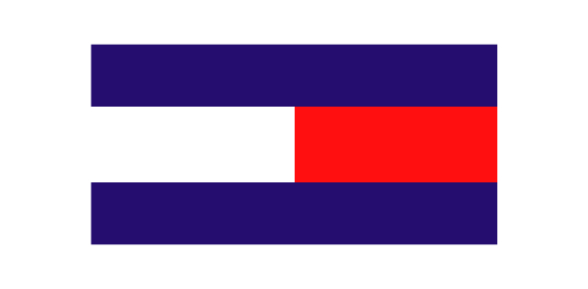

1. Lacoste
2. Tommy Hilfiger
3. Dolce Gabbana
4. Redtape

**CORRECT- B**

1. **Indentify the brand?**

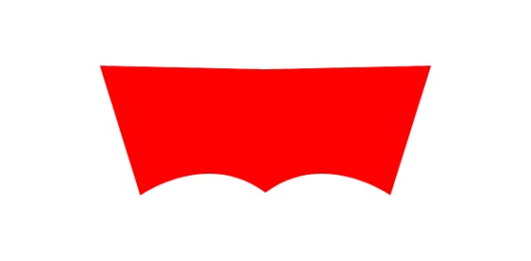

1. North Face
2. Reebok
3. Levis
4. Superdry

CORRECT- C

1. **What brand is this?**

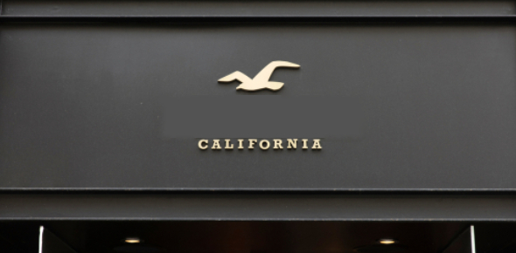

1. Hush puppies
2. Redtape
3. Gucci
4. Hollister

**CORRECT- D**

1. **What brand is this?**

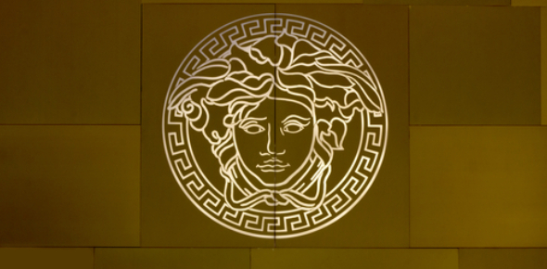

1. Armani
2. Versace
3. Chanel
4. Dolce Gabbana

**CORRECT- B**

1. **What brand is this?**

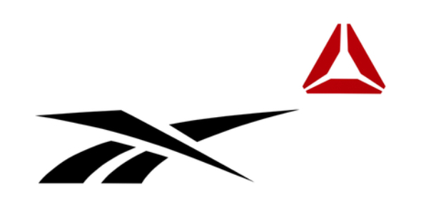

1. Nike
2. Reebok
3. Adidas
4. Gucci

**CORRECT- B**

1. **Indentify the brand?**

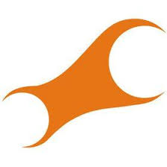

1. Titan
2. Fastrack
3. Casico
4. Timex

**CORRECT- B**

1. **Indentify the brand?**

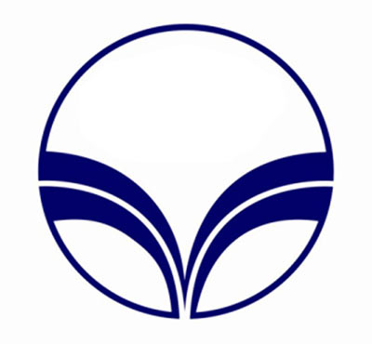

1. Indian Oil
2. Hindustan Petroleum
3. Reliance Petroleum
4. Bharat Petroleum

**CORRECT- B**

1. **Indentify the brand?**

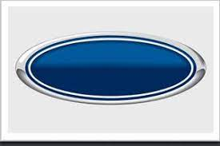

1. Ford
2. Bugatti
3. BMW
4. Carrier

**CORRECT- A**

1. **Indentify the brand?**

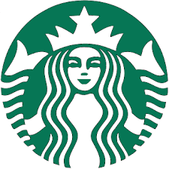

1. Café Coffee Day
2. Starbucks
3. Chaayos
4. Zomato

**CORRECT- B**

1. **What brand is this?**



1. Hindustan Unilever
2. Dabur
3. Godrej
4. Himalaya Herbals

**CORRECT- B**

1. **What brand is this?**

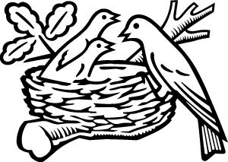

1. Pepsi Co
2. Britannia
3. Parle
4. Nestle

**CORRECT- D**

1. **Indentify the brand?**

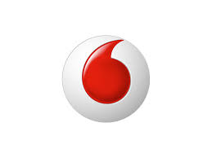

1. MTS
2. Airtel
3. Vodafone
4. BSNL

**CORRECT- C**

1. **Indentify the company logo?**



1. Dr Reddy’s
2. Sun Pharma
3. Piramal Enterprise
4. Bharat Biotech

**CORRECT- C**

1. **Indentify the company logo?**

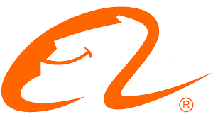

1. Amazon
2. Alibaba
3. Tata Cliq
4. Flipkart

**CORRECT- B**

1. **Indentify the company logo?**

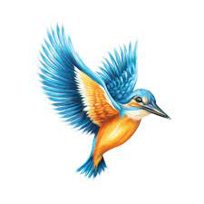

1. Tuborg
2. Budweiser
3. Kingfisher
4. Haywards

**CORRECT- C**

1. **Indentify the brand?**



1. Zenni Optical
2. EyeBuyDirect
3. Titan Eye Plus
4. Lenskart

**CORRECT- D**

1. **Indentify the company logo?**



1. Vistara
2. Indigo
3. Air India
4. Spice Jet

**CORRECT- A**

1. **Indentify the logo?**



1. Skype
2. Telegram
3. Twitter
4. Zoom

**CORRECT- B**